Q 1: Implement above tasks, show the outputs and attach snapshots.

Import Libraries
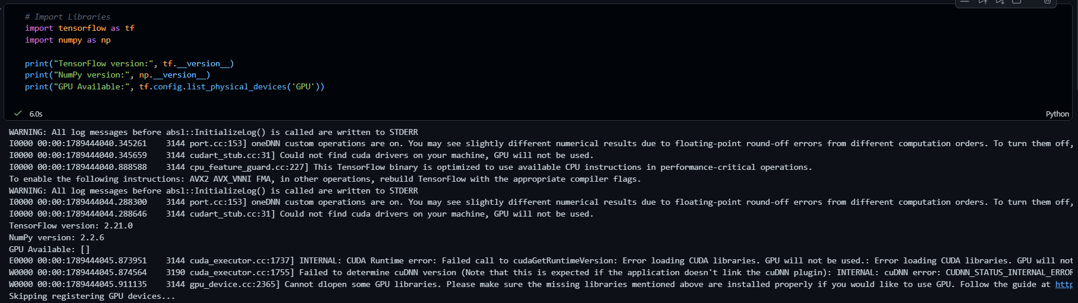

Creating tensors of different ranks
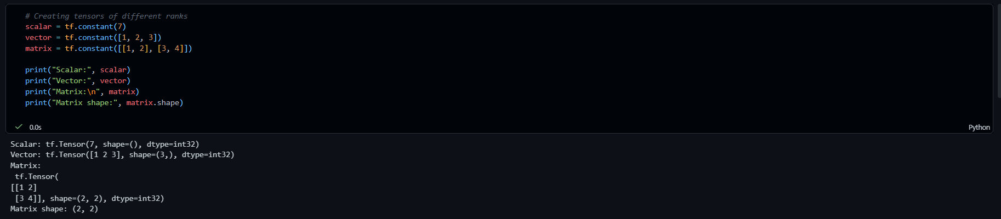

Arithmetic and matrix operations
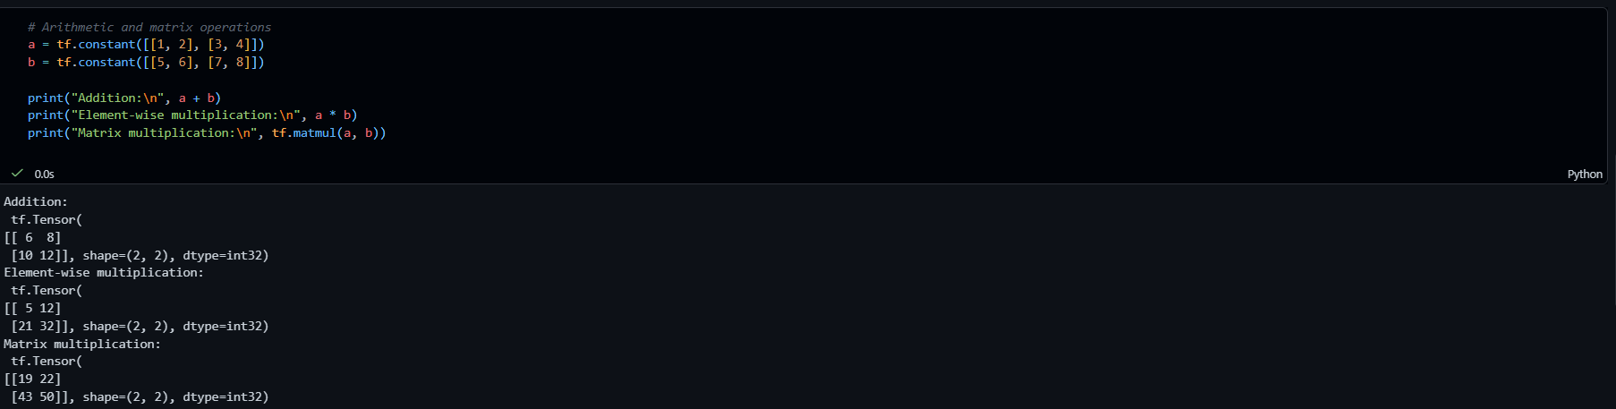

Reshaping and indexing
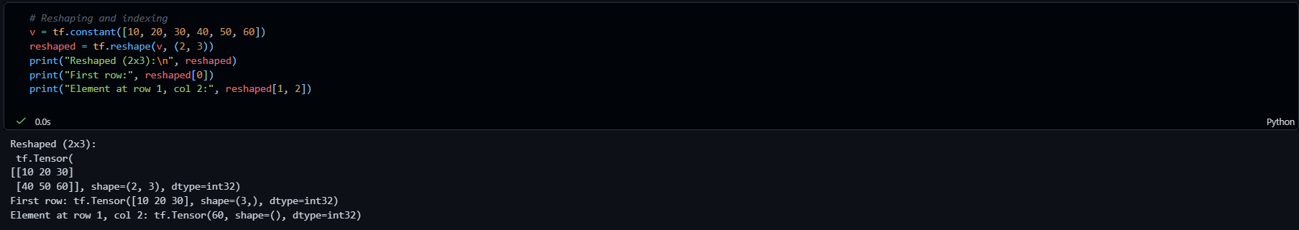

Converting between NumPy and TensorFlow
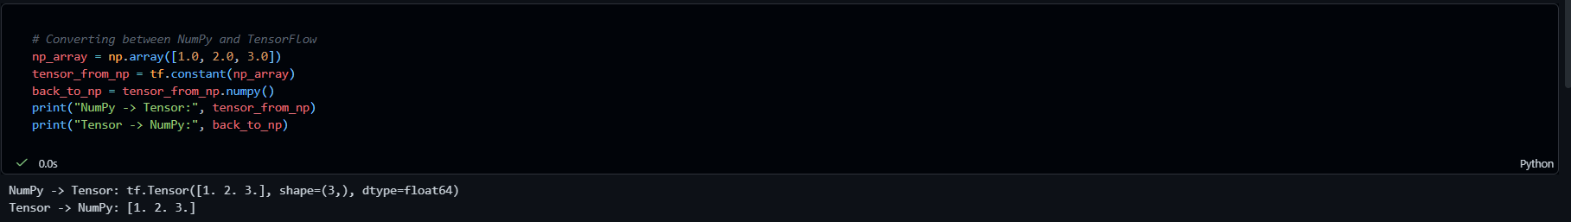

Reviewing a Real Dataset
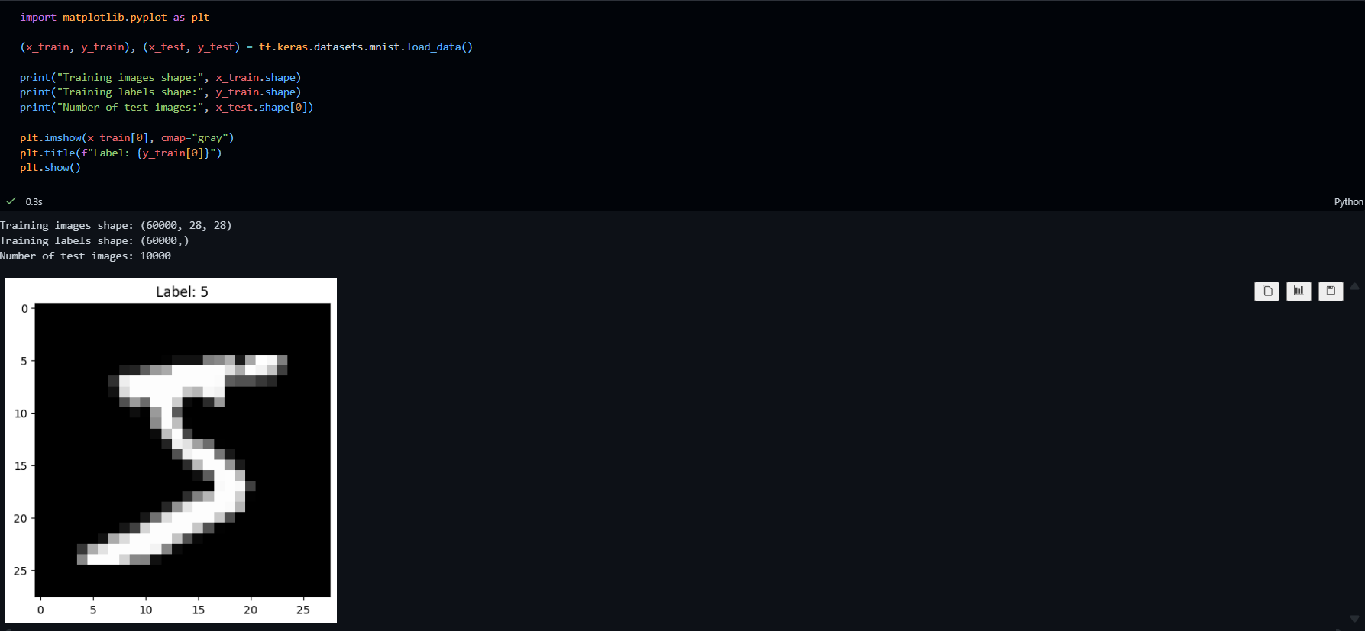

Implementing a Single Neuron
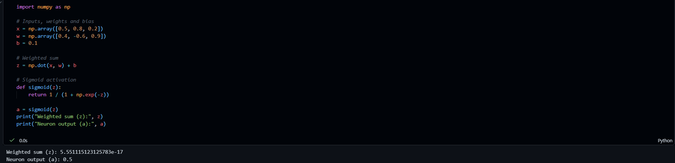

Q2: Differentiate between Machine Learning and Deep Learning with one real-world example of each.

Machine Learning (ML) is a subset of artificial intelligence where algorithms learn patterns from structured data using statistical methods and explicit, hand-engineered feature extraction. Deep Learning (DL) is a specialized subset of machine learning that relies on multi-layered artificial neural networks to automatically extract hierarchical features from unstructured data

Machine Learning Example: Email Spam Filtering
- How it works: A traditional classification algorithm (e.g., Naive Bayes or Logistic Regression) predicts whether an email is spam based on explicitly engineered tabular features, such as keyword counts ("win", "free"), sender reputation score, and capital letter frequency.
Deep Learning Example: Autonomous Vehicle Object Detection
- How it works: A Convolutional Neural Network (CNN) processes raw video frames from vehicle cameras. Without explicit manual rules, early layers detect simple edges, middle layers combine edges into shapes, and deep layers recognize full objects (pedestrians, lane markers, traffic lights) in real time.

Q3: Why is a GPU preferred over a CPU for training deep neural networks?

GPUs are preferred over CPUs for training deep neural networks because deep learning heavily relies on massive parallel processing and matrix math, areas where GPU hardware architecture fundamentally outperforms a CPU.

Key Architectural Differences:
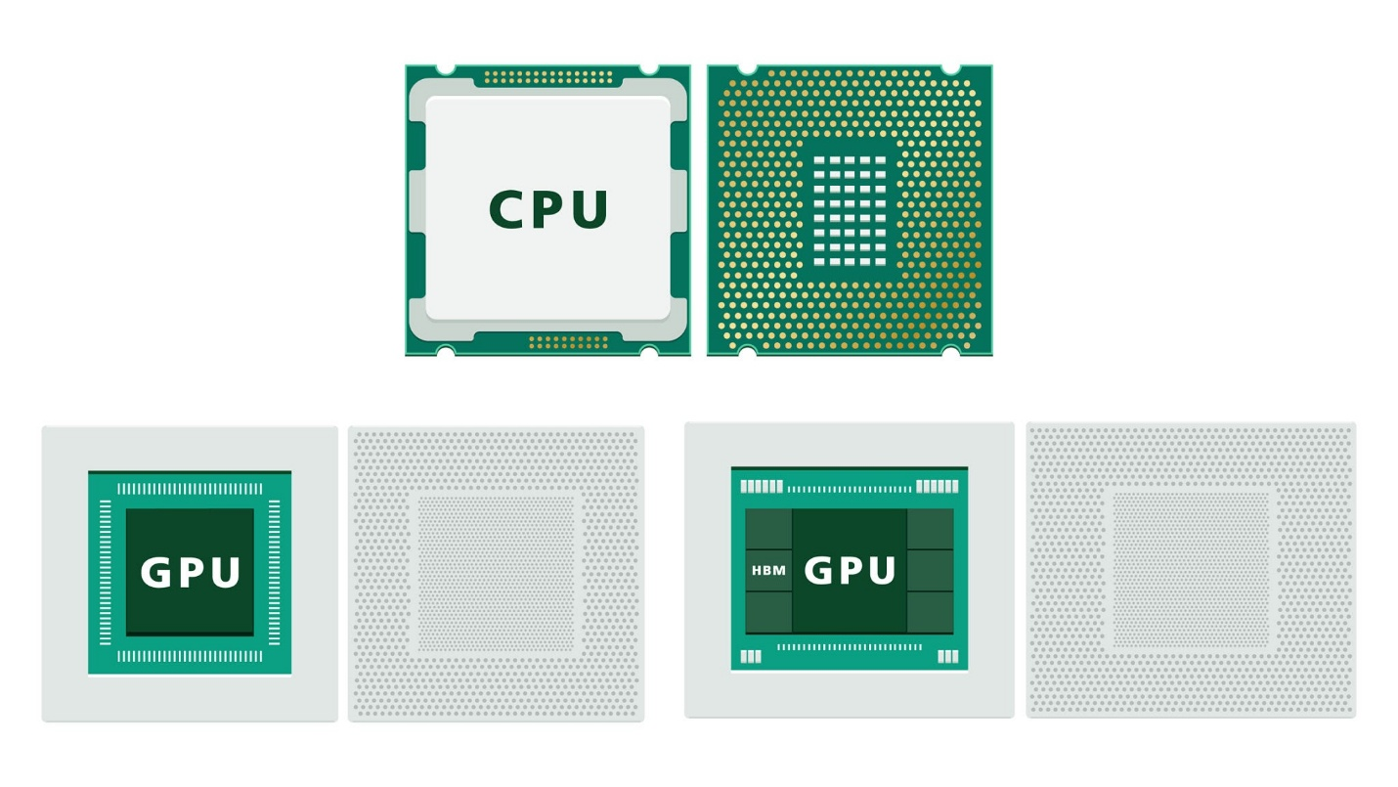

- Massive Parallel Processing: Deep learning operations (like matrix multiplication across layers) can be split into thousands of independent calculations. A GPU contains thousands of Stream Processors / CUDA Cores designed to execute these operations simultaneously (SIMD—Single Instruction, Multiple Data architecture).
- Vector & Matrix Multiplication Acceleration: Forward and backward passes compute $Y=W⋅X+B$. While a CPU processes these operations serially or in small vector blocks, GPUs compute entire matrix blocks in parallel.
- High Memory Bandwidth: Deep learning models constantly shuttle huge amounts of weights and activations between memory and processing units. Modern GPU VRAM (e.g., GDDR6, HBM) offers significantly higher memory bandwidth (up to 2–3 TB/s) compared to standard system RAM used by CPUs.
- Dedicated AI Accelerators: Hardware features like Tensor Cores specialize in mixed-precision matrix arithmetic (FP16/BF16/FP8), drastically speeding up gradient calculations during backpropagation.

Q4: What would happen to a neural network's ability to learn if activation functions were removed from every layer? Justify your answer.

If activation functions were removed from every layer, a deep neural network would collapse into a single linear model, completely losing its ability to learn complex, non-linear patterns or relationships in data.
Why the Network Collapses (Mathematical Justification)
Without non-linear activation functions, every layer in a neural network performs only a linear transformation:
$$y=W⋅x+b$$
When you stack multiple linear layers back-to-back, the output of the network becomes a composite of linear operations:
$$\text{Output}=W_{n}⋅\left(W_{n-1}…\left(W_{2}⋅\left(W_{1}⋅x+b_{1}\right)+b_{2}\right)…+b_{n-1}\right)+b_{n}$$
By expanding and grouping the terms, the entire multi-layer network simplifies to:
$$\text{Output}=W_{\text{effective}}⋅x+b_{\text{effective}}$$
where $W_{\text{effective}}=W_{n}⋅W_{n-1}…W_{1}$ and $b_{\text{effective}}$ is a combination of all bias terms.
Key Consequences
- Loss of Expressivity: No matter how many layers or neurons you add (10 layers or 100 layers), the model can only learn linear decision boundaries (straight lines, flat planes, or hyperplanes).
- Inability to Solve Complex Problems: Real-world data (images, audio, text, housing prices with non-linear trends) requires non-linear decision boundaries. Without activation functions, the network cannot even solve simple non-linear problems like the XOR gate.
- Redundancy of Depth: Stacking deeper layers provides zero additional learning capacity over a single-layer linear regression or single-layer perceptron.

Q5: Using x = [1.0, 0.3, -0.5], w = [0.2, 0.8, -0.1], and b = 0.05, manually calculate the neuron's weighted sum z and its output using the ReLU activation function.

Code:
Import numpy as np
x = np.array([1.0, 0.3, -0.5])
w = np.array([0.2, 0.8, -0.1])
b = 0.05
z = np.dot(x, w) + b
relu_out = max(0.0, z)
print(f"x dot w: {np.dot(x, w)}")
print(f"z: {z}")
print(f"ReLU(z): {relu_out}")

output:
x dot w: 0.49
z: 0.54
ReLU(z): 0.54

1. Weighted Sum Calculation ($z$)
The weighted sum $z$ for a single neuron is defined as:
$$z=\sum_{i=1}^{n}{\left(x_{i}⋅w_{i}\right)}+b=\left(x_{1}⋅w_{1}\right)+\left(x_{2}⋅w_{2}\right)+\left(x_{3}⋅w_{3}\right)+b$$
- Term 1: $1.0×0.2=0.20$
- Term 2: $0.3×0.8=0.24$
- Term 3: $-0.5×\left(-0.1\right)=0.05$
Adding the dot product terms and the bias $b=0.05$:
$$z=0.20+0.24+0.05+0.05=0.54$$
2. ReLU Activation Function Calculation
The Rectified Linear Unit (ReLU) activation function is defined as:
$$\text{ReLU}\left(z\right)=\max\left(0,z\right)$$
Since $z=0.54>0$:
$$\text{ReLU}\left(0.54\right)=\max\left(0,0.54\right)=0.54$$
Final Results
Parameter / Step | Calculated Value
Dot Product ($x⋅w$) | $$0.49$$
Bias ($b$) | $$0.05$$
Weighted Sum ($z$) | $$0.54$$
Neuron Output ($\text{ReLU}\left(z\right)$) | $$0.54$$

Q6: List two advantages and two limitations of using Google Colab for Deep Learning practicals compared to a local installation.

Advantages of Google Colab
- Free Hardware Acceleration (GPUs/TPUs): Colab provides access to high-performance cloud hardware (such as NVIDIA GPUs and TPUs) at zero cost. This allows you to train deep learning models significantly faster without needing to purchase expensive local hardware.
- Zero Configuration & Instant Collaboration: Colab runs entirely in the cloud browser with deep learning frameworks (TensorFlow, PyTorch, CUDA drivers) pre-installed. You can instantly share, comment, and co-edit notebooks with others via Google Drive without dealing with complex local virtual environments or driver setup issues.
Limitations of Google Colab
- Session Timeouts & Non-Persistent Runtimes: Colab sessions disconnect due to inactivity or when maximum runtime limits are reached (typically 12 hours for the free tier). When a runtime disconnects, all temporary files, unbacked data, and in-memory model weights are wiped.
- Resource Constraints & Strict Usage Limits: High-end hardware access is allocated dynamically and subject to daily usage caps or peak-time availability throttling. Free users may run into strict GPU RAM limits, leading to Out of Memory (OOM) errors during large batch training.

